**Sentiment Analysis Using RNN Documentation**

The purpose of this task is to find out whether a customer review is **positive** or **negative** using **deep learning**. For this, we used a special type of neural network called **Recurrent Neural Network (RNN)**, which works well with text data.

**Tools and Libraries Used:**

* **Python** – Programming language
* **Pandas** and **NumPy** – To manage and work with data
* **Regular Expressions (re)** – To clean the text
* **scikit-learn** – To split the data
* **TensorFlow Keras** – To build and train the deep learning model
* **Flask (optional)** – To make a web app for real-time prediction

**Steps in the Project:**

**1. Loading the Data**

The CSV file is loaded, and the column names are displayed to see what kind of data is inside.



**2. Cleaning the Text**

Unnecessary symbols, numbers, and punctuation are removed from the reviews using regular expressions to make the data clean and simple for the model.

**3. Converting Text to Numbers**

Since models can’t understand text directly:

* We use a **Tokenizer** to change words into numbers.
* Then, we **pad the sequences** so all inputs have the same length.

**4. Splitting the Data**

The data is divided into two parts:

* One part is used to **train the model**
* The other part is used to **test how well the model performs**

**5. Building the Model**

The model has three main parts:

* **Embedding Layer**: Converts word numbers into vectors
* **RNN Layer**: Reads the sequence of words
* **Output Layer**: Tells us if the review is positive or negative



**6. Training the Model**

The model is trained using the training data. It learns patterns from the reviews and adjusts itself to make better predictions.

**7. Testing the Model**

After training, the model is tested using new data it hasn’t seen before. This shows how good the model is.

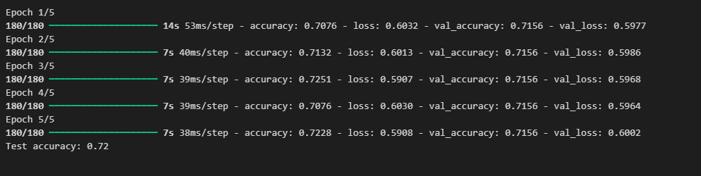

**8. Making Predictions**

A user can type any review (like "The food was amazing"), and the model will tell if it’s **positive** or **negative**.

